|  |  |  |  |  |  |  |  |  |  |
| --- | --- | --- | --- | --- | --- | --- | --- | --- | --- |
| **SCHOOL OF COMPUTER SCIENCE AND ARTIFICIAL INTELLIGENCE** | | | | | **DEPARTMENT OF COMPUTER SCIENCE ENGINEERING** | | | | |
| **ProgramName:**B. Tech | | | | **Assignment Type: Lab** | | | **AcademicYear:**2025-2026 | | |
| **CourseCoordinatorName** | | | | Venkataramana Veeramsetty | | | | | |
| **Instructor(s)Name** | | | | 1. Dr. Mohammed Ali Shaik  2. Dr. T Sampath Kumar  3. Mr. S Naresh Kumar  4. Dr. V. Rajesh  5. Dr. Brij Kishore  6. Dr Pramoda Patro  7. Dr. Venkataramana  8. Dr. Ravi Chander  9. Dr. Jagjeeth Singh | | | | | |
| **CourseCode** | | | 24CS002PC215 | **CourseTitle** | | AI Assisted Coding | | | |
| **Year/Sem** | | | II/I | **Regulation** | | R24 | | | |
| **Date and Day**  **of Assignment** | | |  | **Time(s)** | |  | | | |
| **Duration** | | | 2 Hours | **Applicableto**  **Batches** | |  | | | |
| **AssignmentNumber:3.3**(Present assignment number)/**24**(Total number of assignments) | | | | | | | | | |
|  | | | | | | | | | |
|  | **Q.No.** | **Question** | | | | | | ***ExpectedTime***  ***to complete*** |  |
|  | 1 | Lab 3: Prompt Engineering – Improving Prompts and Context Management  **Lab Objectives:**   * To understand how prompt structure and wording influence AI-generated code. * To explore how context (like comments and function names) helps AI generate relevant output. * To evaluate the quality and accuracy of code based on prompt clarity. * To develop effective prompting strategies for AI-assisted programming.   **Lab Outcomes (LOs):**  After completing this lab, students will be able to:   * Generate Python code using Google Gemini in Google Colab. * Analyze the effectiveness of code explanations and suggestions by Gemini. * Set up and use Cursor AI for AI-powered coding assistance. * Evaluate and refactor code using Cursor AI features. * Compare AI tool behavior and code quality across different platforms.   **Task Description#1**   * Try 3 different prompts to generate a factorial function.   **Expected Output#1**   * Comparison of AI-generated code styles   **Task Description#2**   * Provide a clear example input-output prompt to generate a sorting function.   **Expected Output#2**   * Functional sorting code from AI   **Task Description#3**   * Start with the vague prompt “Generate python code to calculate power bill” and improve it step-by-step   **Expected Output#3**   * Enhanced AI output with clearer prompts   **Task Description#4**   * Write structured comments to help AI generate two linked functions (e.g., login_user() and register_user()).   **Expected Output#4**   * Consistent functions with shared logic   **Task Description#5**   * Analyzing Prompt Specificity: Improving Temperature Conversion Function with Clear Instructions   **Expected Output#5**   * Code quality difference analysis for various prompts   **Note: Report should be submitted a word document for all tasks in a single document with prompts, comments & code explanation, and output and if required, screenshots**  **Evaluation Criteria:**   | **Criteria** | **Max Marks** | | --- | --- | | Factorial Function (Task#1) | 0.5 | | Sorting Function (Task#2) | 0.5 | | Vogue Vs. Specific Prompting (Task #3) | 0.5 | | Linked Functions (Task #4) | 0.5 | | Temperature Conversion Function (Task #5) | 0.5 | | **Total** | **2.5 Marks** | | | | | | | 03.08.2025 EOD |  |

**Task Description#1**

* Try 3 different prompts to generate a factorial function.

**Expected Output#1**

* Comparison of AI-generated code styles

PROMPT 1:

Write a python program to find a factorial of a given number in iteration ?

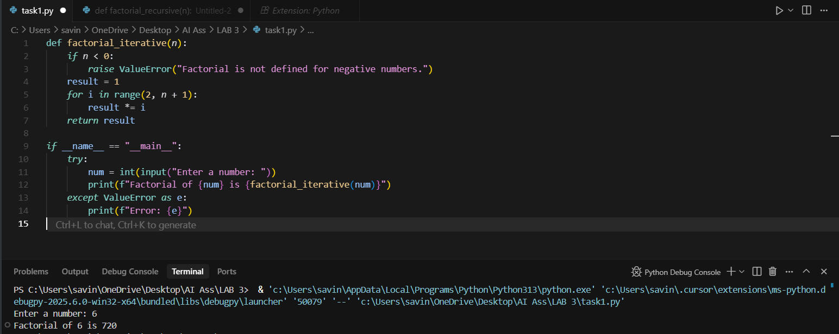

PROMPT 2:

Write a python program to find a factorial of a given number in recursive ?

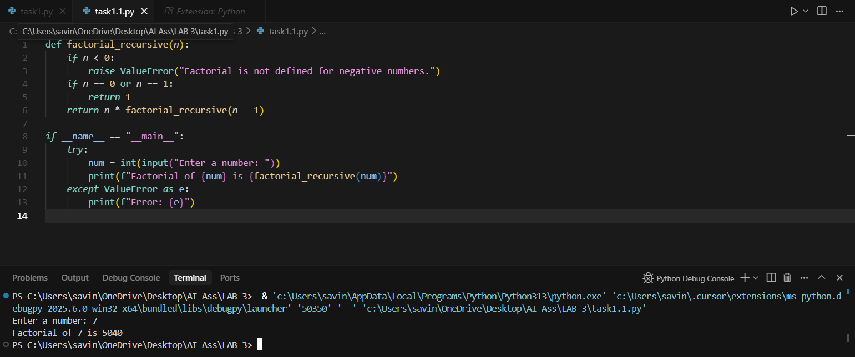

PROMPT 3:

**Task Description#2**

* Provide a clear example input-output prompt to generate a sorting function.

**Expected Output#2**

* Functional sorting code from AI

PROMPT :

**Write a python program using sorting function in input-output form?**

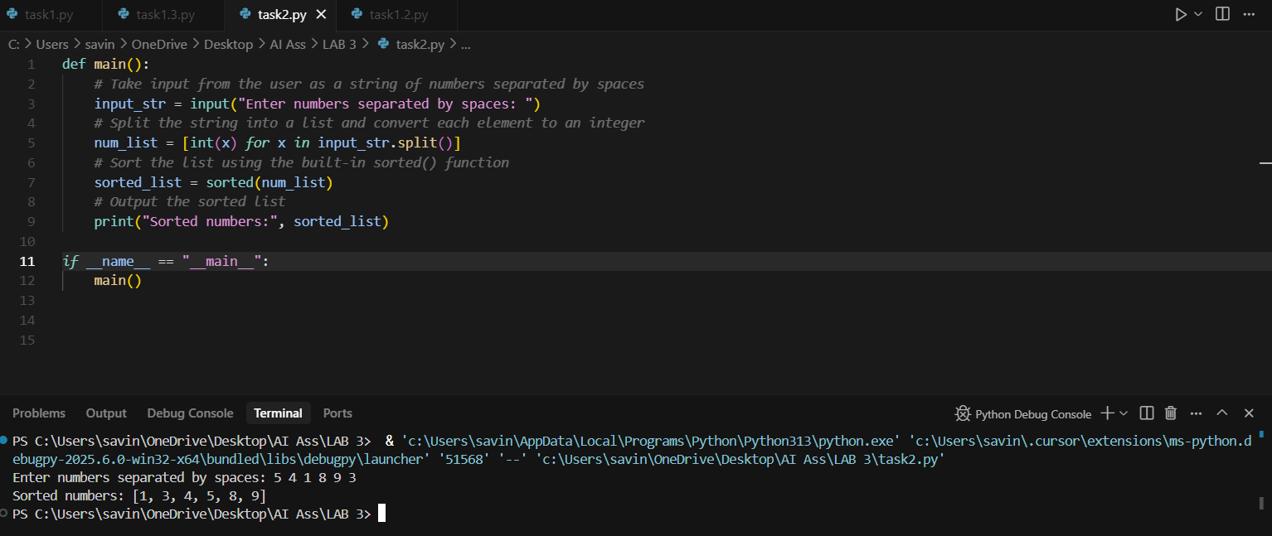

**Task Description#3**

* Start with the vague prompt “Generate python code to calculate power bill” and improve it step-by-step

**Expected Output#3**

* Enhanced AI output with clearer prompts .

PROMPT :

**write a python program to calculate the power bill and improve it step by step ?**

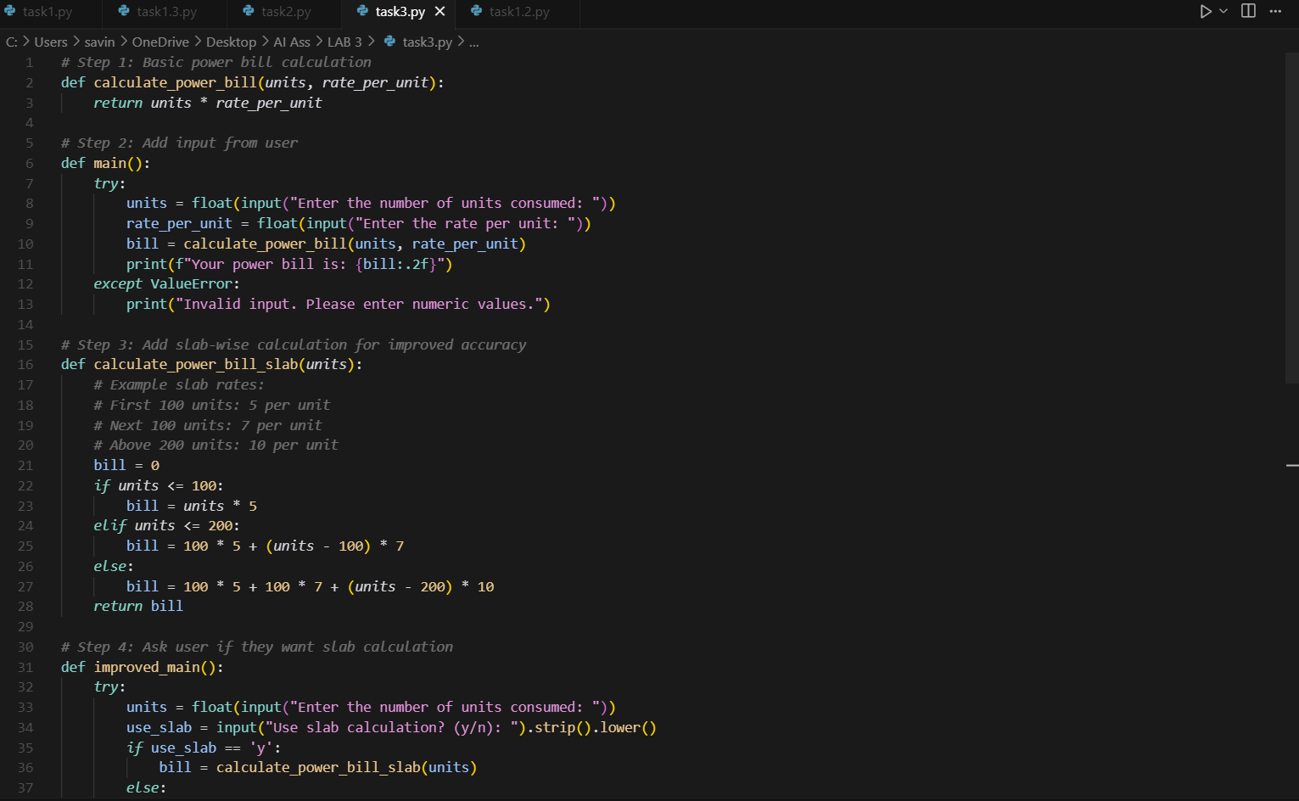

**Task Description#4**

* Write structured comments to help AI generate two linked functions (e.g., login_user() and register_user()).

**Expected Output#4**

* Consistent functions with shared logic.

PROMPT :

Give me the code to create two python linked functions that are login user and register user and ask the user to give the input as username and password and display the result on to the screen

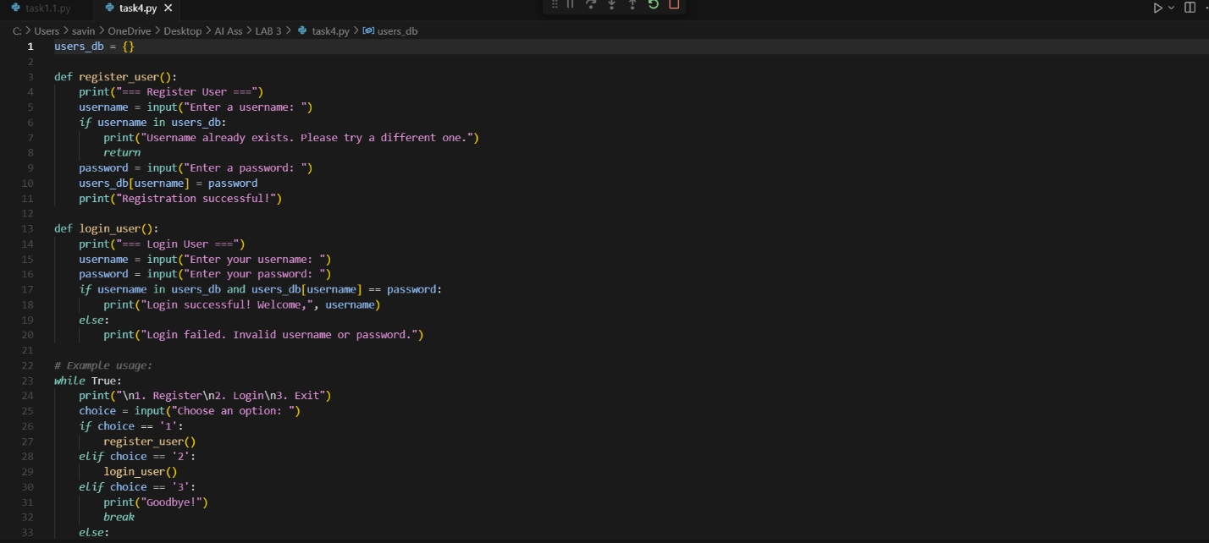

**Task Description#5**

* Analyzing Prompt Specificity: Improving Temperature Conversion Function with Clear Instructions

**Expected Output#5**

* Code quality difference analysis for various prompts

PROMPT :

write a pytthon function to read the input and also for improving the tempearture conversion with clear instructions.



